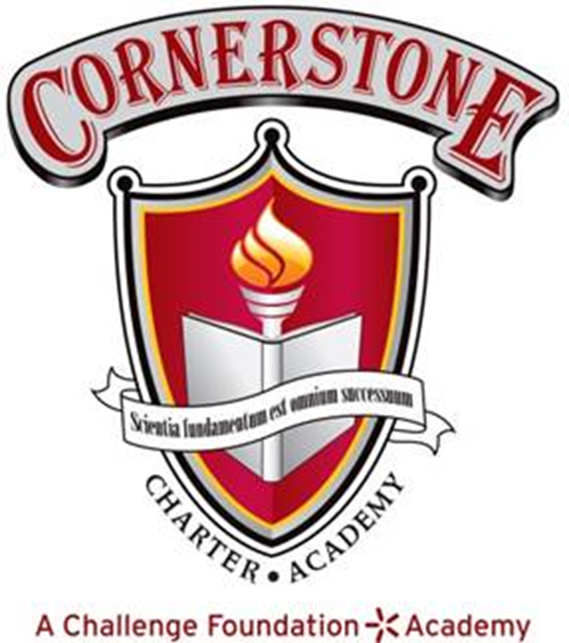

October 16, 2025 6:00 P.M.
Regular Meeting of the Board of Directors
7800 Airport Center Drive, Greensboro, NC

Cornerstone Charter Academy Library

Meeting Minutes

Member Attendance

 | Jonetta Appling | Liz Goetzinger | Ryan Homer | Aditya Pandit | Crystal Scillitani | Cyndie Swindlehurst | Andrew Wright
7.10.25 | phone | phone | absent | absent | phone | phone | phone
7.17.25
8.21.25 | present | present | present | present | present | present | present
9.18.25 | present | present | absent | absent | phone | present | present
10.17.25 | present | present | absent | present | absent | present | present

- Call to Order Time: 6:07 pm

- Motion to approve agenda Jonetta/Aditya/all

- Pledge of Allegiance

- Mission Statement:
  - Cornerstone Charter Academy, a tuition-free public charter school, will give every student the opportunity to reach his or her potential by providing a rigorous academic program, character education and meaningful parental participation.

- Motion to approve minutes for September 18, 2025 Cyndie/Andrew/all

- Building Expansion Items Joe Caraher/John Lewis
  - Budget
  - Project status
  - Timelines and Meetings
  - ECPI Renovation Update

- ECPI Project Update and Projections Joe Caraher

- New Business
  - Motion to authorize Joe Caraher to submit application for Title I & II funds.
Liz/Andrew/all
  - Motion to approve the Parent and Family Engagement Plan Policy
Cyndie/Aditya/all

- Actionable Items from Committee
  - Motion from Finance to transfer money to investment account.
All in Favor

- Reports to the Board
  - Director’s Report Joe Caraher

- Public Comment - none

- Executive Session for discussion of confidential personnel matters.
Cyndie/Jonetta/all Time: 7:06 pm
- Return to open session Cyndie/Andrew/all Time: 7:58 pm

- Motion to adjourn Cyndie/Jonetta/all Time: 7:58 pm

Minutes submitted on: November 17, 2025
Minutes approved on: November 20, 2025

_Jonetta Appling___________
Jonetta Appling, board secretary

