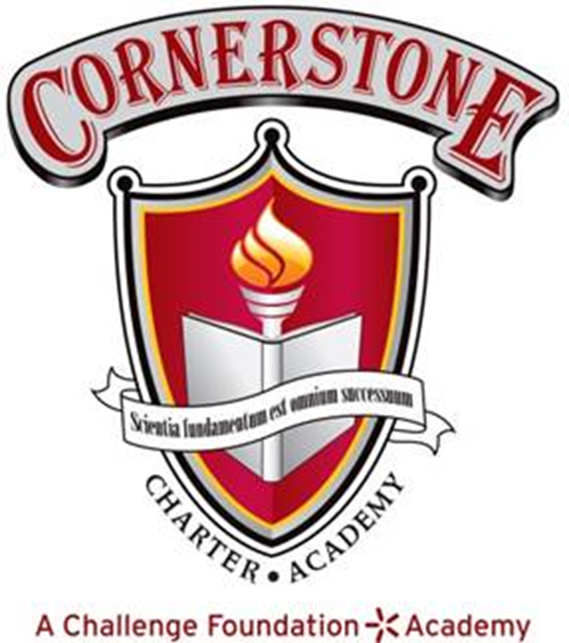

September 18, 2025 6:00 P.M.
Regular Meeting of the Board of Directors
7800 Airport Center Drive, Greensboro, NC

Cornerstone Charter Academy Library

Meeting Minutes

Member Attendance

 | Jonetta Appling | Liz Goetzinger | Ryan Homer | Aditya Pandit | Crystal Scillitani | Cyndie Swindlehurst | Andrew Wright
7.10.25 | phone | phone | absent | absent | phone | phone | phone
7.17.25 | present | phone | phone | phone | present | present | phone
8.21.25 | present | present | present | present | present | present | present
9.18.25 | present | present | absent | absent | phone | present | present

- Call to Order Time: 6:00pm

- Motion to approve agenda Jonetta/Andrew/all

- Pledge of Allegiance

- Mission Statement:
  - Cornerstone Charter Academy, a tuition-free public charter school, will give every student the opportunity to reach his or her potential by providing a rigorous academic program, character education and meaningful parental participation.

- Motion to approve minutes for August 21, 2025 Andrew/Liz/all

- Tour of Construction Site Joe Caraher/John Lewis

- Building Expansion Items Joe Caraher/John Lewis
  - Budget
  - Project status
  - Timelines and Meetings
  - ECPI Renovation Update

- 2024-2025 Achievement Data Joe Caraher

- New Business
  - Motion to approve a new term for Ryan to remain on the board for the next 3 years Cyndie/Jonetta/all

- Actionable Items from Committee
  - Motion from Governance to retire the Academic Policy, all in favor.

- Reports to the Board
  - Director’s Report Joe Caraher

- Public Comment - none

- Motion to adjourn Cyndie/Liz/all Time: 7:28 pm

Minutes submitted on: October 4, 2025
Minutes approved on: October 16, 2025

_Jonetta Appling___________
Jonetta Appling, board secretary

